K12 Bollard - PAS68 Static Bollards – ESF – SIM - T50ST
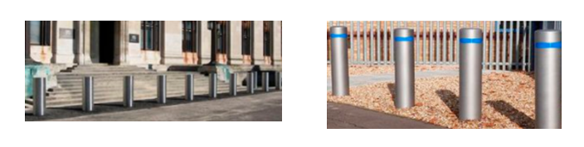

- PAS68: V/7500[N2]/80/90:1.0/21.2 Certified.
- Bollard tested with N2 & N3 7.5ton vehicle at 50mph / 80kmh
- Diameter: 273mm
- Height: 1000mm above FFL
- Finish: Stainless-Steel Sleeve
- Foundation: 750mm, plus 75mm blinding and allowance for 100mm topping.
- Static fixed option.
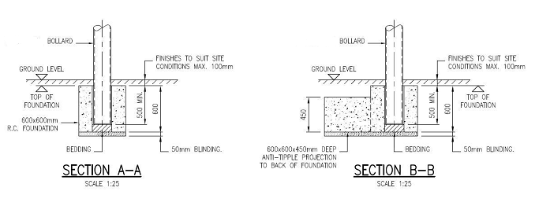
- Test Certificate Supplied

